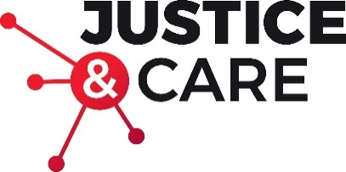

Equality and diversity monitoring form

Justice and Care wants to meet the aims and commitments set out in its equality policy.
It would be helpful if you could answer a few anonymous questions which will help us ensure that we are reaching out to all sections of our community.

The information provided will be kept confidential and will be used only for monitoring purposes- it will not be used as part of the selection process and will not be disclosed to the selection panel.

Gender Male ☐ Female ☐ Intersex ☐ Non-binary ☐ Prefer not to say ☐
If you prefer to use your own gender identity, please write in:

Is the gender you identify with the same as your gender registered at birth?
Yes ☐ No ☐ Prefer not to say ☐

Age 16-24 ☐ 25-29 ☐ 30-34 ☐ 35-39 ☐ 40-44 ☐ 45-49 ☐ 50-54 ☐ 55-59 ☐ 60-64 ☐ 65+ ☐ Prefer not to say ☐
Ethnicity

Asian or Asian British
Indian ☐ Pakistani ☐ Bangladeshi ☐ Chinese ☐ Prefer not to say ☐
Any other Asian background, please write below:

Black, African, Caribbean or Black British
African ☐ Caribbean ☐ Prefer not to say ☐
Any other Black, African or Caribbean background, please write below:

Mixed or Multiple ethnic groups
White and Black Caribbean ☐ White and Black African ☐ White and Asian ☐ Prefer not to say ☐ Any other Mixed or Multiple ethnic background, please write below:

White
English ☐ Welsh ☐ Scottish ☐ Northern Irish ☐ Irish ☐
British ☐ Gypsy or Irish Traveller ☐ Prefer not to say ☐
Any other White background, please write below:

Other ethnic group
Arab ☐ Prefer not to say ☐ Any other ethnic group, please write below:

Do you consider yourself to have a disability or health condition?
Yes ☐ No ☐ Prefer not to say ☐

What is your sexual orientation?
Heterosexual  Gay  Lesbian  Bisexual  Asexual  Pansexual 
Undecided  Prefer not to say 
If you prefer to use your own identity, please write below:

